- Create a data model and connect all the four tables given in the data set - inventory, products, sales, and store.

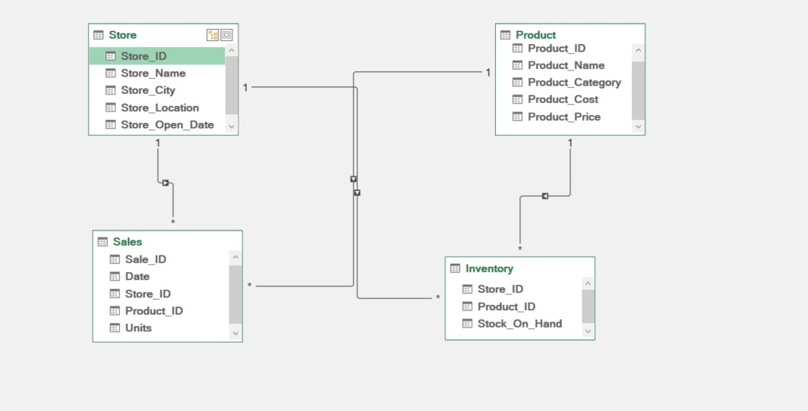
- Use the VLOOKUP functionality to achieve the above task.

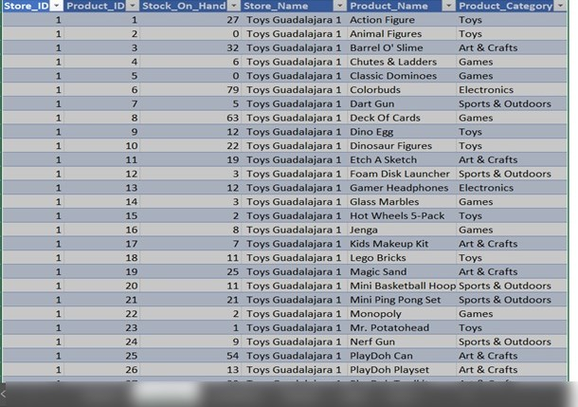

- Create a chart based on the sales across stores and products.

Chart on the basis of sum of unit, store and Product.

4. Create a chart based on the inventory details across stores and products.

5. Create a product category slicer that can display the Stock_On_Hand details for each category from the inventory.
